Java

API 🡪 Predefined 🡪 .class, .package, interface = .jar

Predefined Packages:

Java.lang.\*; (\* Is a wild character which will be unpack all the modules in the package)

All .class files (Default package)

Java.utility.\*;

Collection (API + Algorithm)

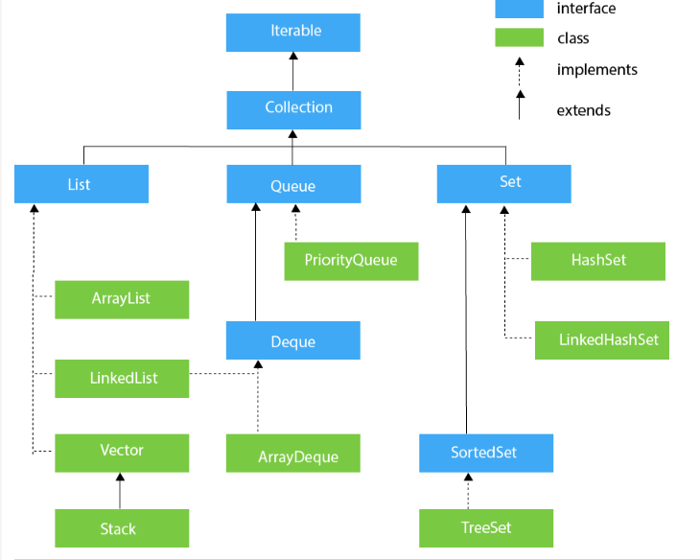

Set (Interface)

* + Collection of objects but not primitive data types
  + Dynamic in size
  + No duplicates in the set (Not the duplicate data but from same memory address)
  + While Iterating no order is maintained
  + Set extends Collection extends Iterator
* Complete / Concrete / Implementation Class
  + HashSet 🡪 un sorted
  + LinkedHashSet (Double Linked)
  + TreeSet 🡪 Sorted